**ECP4 Project Proposal: Active Filter with Gate Driver and MOSFET**

**Authors: Yaoxia Guan and Adiba Asad**

[**yguan4@gmu.edu**](mailto:yguan4@gmu.edu)[**aasad6@gmu.edu**](mailto:aasad6@gmu.edu)

**George Mason University - Fall 2023**

**Background:**

There are three main physical components in this experiment: the gate driver, the Si MOSFET, and the active filter. The gate driver is an electronic device that is used to control the voltage and current applied to the gate of a power semiconductor device, such as a MOSFET. It ensures that the gate of the semiconductor device switches on and off rapidly and reliably. In this experiment, the gate driver will be used to control the input signal of the MOSFET.

The Silicon MOSFET is a transistor which is used to control the voltage across the parts of this device and/or as a switch. There are two types of MOSFETs, NMOS which has a N-type as the source and drain and P-type as the substrate, while the PMOS is the opposite. The main differences between the two is the NMOS is faster and more commonly used than the PMOS, the PMOS is less prone to noise, and the NMOS has a smaller footprint than PMOS for the same output current. Since we plan to observe the effect of an active filter on the amount of noise produced, the NMOS will be used.

The NMOS is built on a p-type substrate with two heavily n-type regions, between the two n-regions there is a thin film of silicon oxide grown on top which acts as an insulator. The metal cap is then placed on top of this film as well as on the source, drain, and the body.

The operation of the MOSFET starts with the threshold voltage of a silicon MOSFET which is the minimum voltage applied to its gate relative to the source. In other words, this is needed to create an induced n-channel which initiates conduction between the drain and source terminals. It defines the point at which the MOSFET transitions from an off state to an on state, making it a critical parameter in determining when the transistor activates in electronic circuits.

There are two main regions of operation of the MOSFET, the triode and the saturation region. By applying a small voltage at the drain, an induced n-channel is formed between the source and the drain which creates an electric field and allows electrons to flow from the source to the drain. In other words, this is what causes current to flow and creates these two regions of operation. When the voltage across the drain and source is much smaller than overdrive voltage, the NMOS is said to be acting in the triode region. However, within the triode region, when the voltage across the drain and source is very small, we notice there is a portion that acts linear. Since it is very small, we can disregard the square term and it is represented by a linear function. As this voltage slowly continues to increase, the channel begins to be pinched and the current flowing through this channel becomes constant, which is known as the saturation region.

As mentioned previously, MOSFETs have some noise in their output due to the signal current interacting with different materials such as silicon. By using certain devices, such as a filter, this noise can be minimized. An active filter uses active components to filter and process electrical signals. It can be designed to perform various filtering operations, such as low-pass, high-pass, band-pass, or band-stop filtering. Active filters are used to shape, clean, or modify signals in applications like audio processing, communication systems, and instrumentation. For this experiment, a low-pass filter will be used to minimize the noise of the MOSFET. However, this causes a problem as the filter also has an effect on the operation of the MOSFET. By having the filter, the noise may decrease, but so will the speed at which the MOSFET will turn “on” and “off”. In other words, there is a tradeoff between speed and noise which will have to be taken into account.

When combined in a circuit, these components can work together in various ways, depending on the specific application. A gate driver may be used to control the switching of a power MOSFET. The gate driver ensures that the MOSFET turns on and off as required, controlling the flow of current through the MOSFET. An active filter may be used in the input or output stage of a circuit to filter out unwanted noise or harmonics and it can help improve the quality of the signal or power being controlled by the MOSFET. Controlled MOSFETs may integrate gate driver circuitry and active filter elements to provide a more comprehensive and integrated solution for controlling and filtering power signals.

**Objectives:**

The objective of this experiment is to observe and analyze the effect of an active filter on the gate driver signal noise. As mentioned previously, the MOSFET has some noise at the output due to the current’s interaction with materials. By adding a low pass filter, we can observe how much of this is minimized. However, the filter also has an effect on the operation of the MOSFET. By having the filter, the noise may decrease, but so will the speed at which the MOSFET will turn “on” and “off”. In other words, there is a tradeoff between speed and noise which will be analyzed as well.

**Procedure/Methods:**

1. Research functionality and applications of the gate driver, Si MOSFET, and the active filter.
2. Design an active low pass filter based on IC (FAN3111CSX)
3. Develop a schematic of the full circuit and simulate in PSPICE
4. Design pcb board using KiCad and order parts
5. Conduct the experiment

**Materials and Equipment:**

| **Part** | **Website** | **Manufacturer** | **Product number** | **Description** | **Cost**  **(QTY = 1)** | **Mount type** | **V supply** | **Peak current** | **Operating Temp** |
| --- | --- | --- | --- | --- | --- | --- | --- | --- | --- |
| Gate Drive | [Here](https://www.digikey.com/en/products/detail/onsemi/FAN3111CSX/2021404) | Onsemi | FAN3111CSX | Low-Side Gate Driver IC Inverting, Non-Inverting SOT-23-5 | $0.93 | Surface mount | 4.5V ~ 18V | 1.4 A | -40°C ~ 150°C |
| Silicon  NMOS | [Here](https://www.digikey.com/en/products/detail/microchip-technology/TN0610N3-G/4902374?utm_adgroup=General&utm_source=google&utm_medium=cpc&utm_campaign=PMax%20Shopping_Product_Zombie%20SKUs&utm_term=&utm_content=General&utm_id=go_cmp-17815035045_adg-_ad-__dev-c_ext-_prd-4902374_sig-CjwKCAjwkNOpBhBEEiwAb3MvveJS0AZX7Hnx71ucpJwPt8qRSxY8LqS0HBQ2qomkiwvlC30oYklZVhoCUNIQAvD_BwE&gclid=CjwKCAjwkNOpBhBEEiwAb3MvveJS0AZX7Hnx71ucpJwPt8qRSxY8LqS0HBQ2qomkiwvlC30oYklZVhoCUNIQAvD_BwE) | Microchip Technology | TN0610N3-G | MOSFET N-CH 100V 500MA TO92-3 | $1.28 | Through-Hole | 2V (Vgs) | 1mA  (Id) | -55°C ~ 150°C |
| Silicon NMOS | [Here](https://www.digikey.com/en/products/detail/onsemi/2N7000-D26Z/2094402?utm_adgroup=General&utm_source=google&utm_medium=cpc&utm_campaign=PMax%20Shopping_Product_Zombie%20SKUs&utm_term=&utm_content=General&utm_id=go_cmp-17815035045_adg-_ad-__dev-c_ext-_prd-2094402_sig-CjwKCAjwkNOpBhBEEiwAb3MvvTu0MH1a1XLTZEqzR2gcWGEvBzmuALJdQpNo5WBH3_v9lQMqZbzUXxoCAh4QAvD_BwE&gclid=CjwKCAjwkNOpBhBEEiwAb3MvvTu0MH1a1XLTZEqzR2gcWGEvBzmuALJdQpNo5WBH3_v9lQMqZbzUXxoCAh4QAvD_BwE) | Onsemi | 2N7000-D26Z | MOSFET N-CH 60V 200MA TO92-3 | $0.41 | Through-Hole | 3V  (Vgs) | 1mA  (Id) | -55°C ~ 150°C |

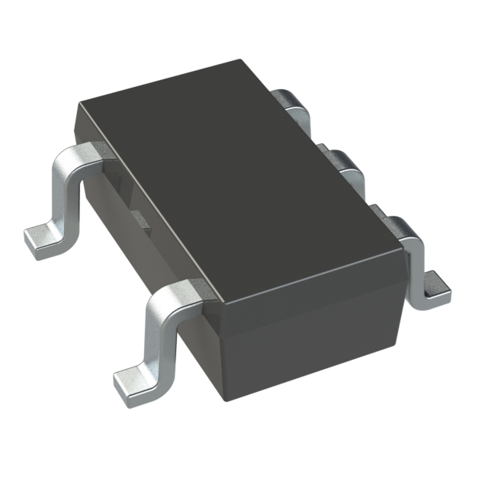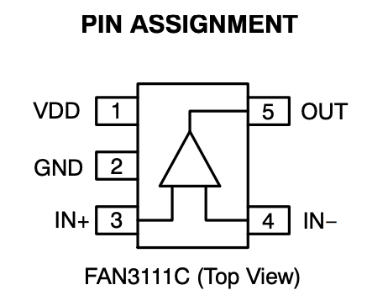

Figure 1: Gate Drive Image (left) and Pin Assignment (right)

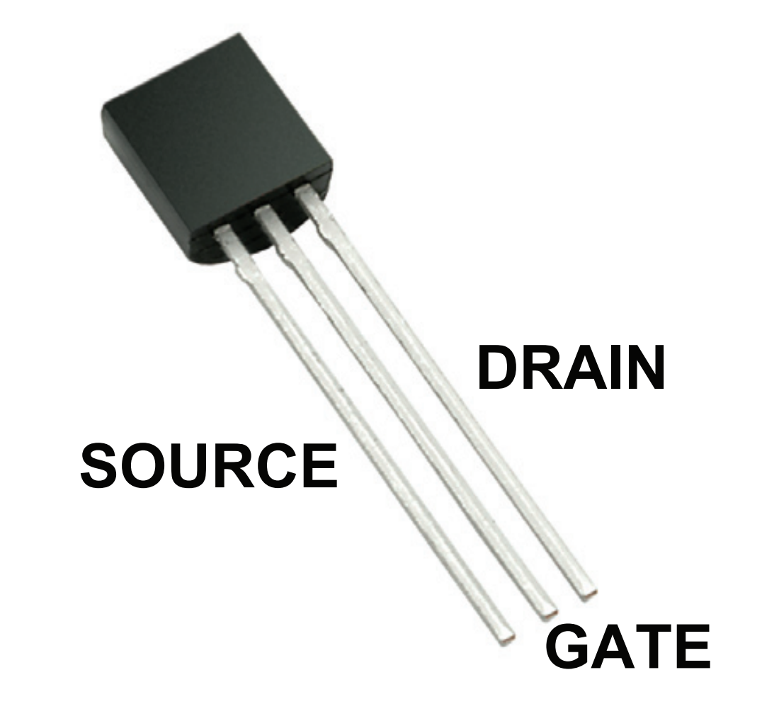

Figure 2: Microchip Technology Through-Hole NMOS

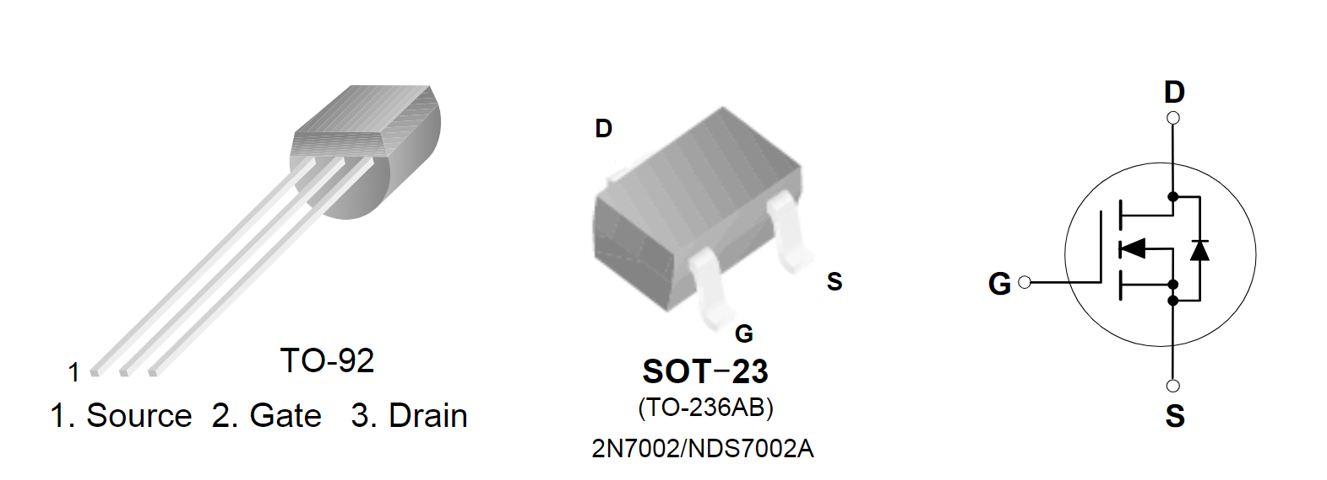

Figure 3: Onsemi Through-Hole NMOS

**Schematic:**

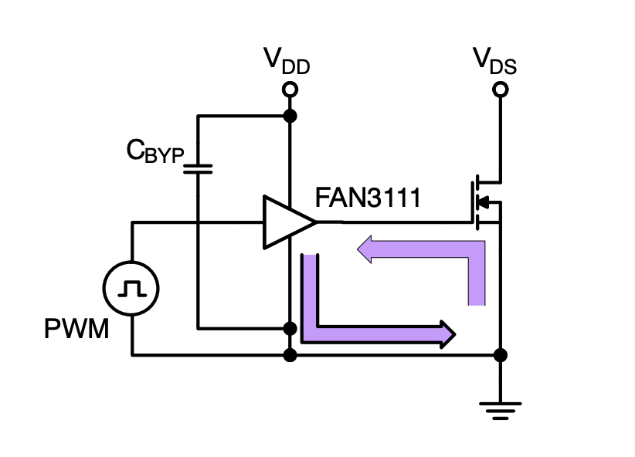

**Components:**

* 10nF Capacitor
* 10k Resistor (cutoff freq is 1.5k ish)
* Gate Driver
* Oscilloscope (10k-1M ish? what frequency)
* Power Supply (2, one for gate driver and the other for MOSFET)
* Signal Generator (2, one for gate driver and the other for MOSFET)
* Si MOSFET

**Schedule:**

The expected time frame for this project is from October 16th, 2023 to November 20th, 2023. The goal is to finish the proposal by October 22nd and have it looked over for additional changes. We will begin simulations and design of circuit on October 23rd and begin building it on KiCad by the end of the week. After approval, during the week of October 30th, we will order the PCB board. Once the PCB arrives, we will begin testing the week of November 6th.